Speed Control Of Induction Motor Using Triac And Diac

Introduction:- Speed control of induction motor Using Triac and diac developed by PROJECT LAB is designed for controlling the speed of small induction motors like sewing machine induction motors, electric fan motors or they can also be used to control brightness of electric bulb upto 100 Watts Rating. The speed of the motor can be controlled by changing the setting of potentiometer. The setting of potentiometer determines the phase of the trigger pulse that fires the triac. The circuit incorporates a self-stabilizing technique that maintains the speed of the motor even when it is loaded.
Schematic Diagram:-
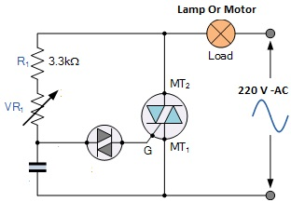

Working:- As the AC supply voltage increases at the beginning of the cycle, capacitor, C is charged through the series combination of the fixed resistor, R1 and the potentiometer, VR1 and the voltage across its plates increases. When the charging voltage reaches the breakover voltage of the diac (about 32 V), the diac breaks down and the capacitor discharges through the diac.
The discharge produces a sudden pulse of current, which fires the triac into conduction. The phase angle at which the triac is triggered can be varied using VR1, which controls the charging rate of the capacitor. Resistor, R1 limits the gate current to a safe value when VR1 is at its minimum.
Once the triac has been fired into conduction, it is maintained in its “ON” state by the load current flowing through it, while the voltage across the resistor–capacitor combination is limited by the “ON” voltage of the triac and is maintained until the end of the present half-cycle of the AC supply.
At the end of the half cycle the supply voltage falls to zero, reducing the current through the triac below its holding current, I_{H} turning it “OFF” and the diac stops conduction. The supply voltage then enters its next half-cycle, the capacitor voltage again begins to rise (this time in the opposite direction) and the cycle of firing the triac repeats over again.

Triac Conduction Waveform

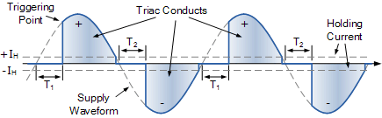

Then we have seen that the Diac is a very useful device which can be used to trigger triacs and because of its negative resistance characteristics this allows it to switch “ON” rapidly once a certain applied voltage level is reached.

